BanrKit OTO 1, 2, 3-- All 4 OTOs'
https://banrkit.com/banrkit-sales-page-jvzoo/
by BanrKit Crew
BanrKit OTO 1, 2, 3: There is a professional Agency as front end alternative and also 3 various other OTOs. The 2nd BanrKit OTO is Ultimate Agency, the 3rd is Pushas well as the 4th is Agency Kit. There are no other down sell. The product is by Patrick Ngambi.
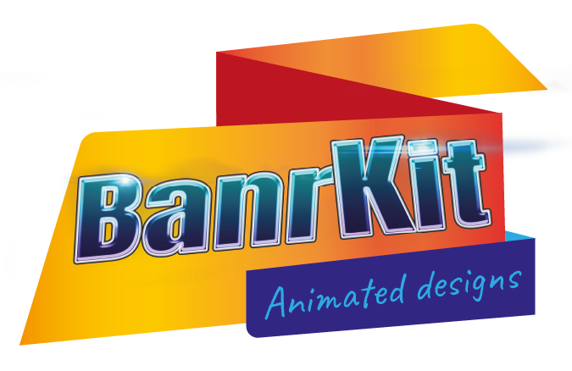
All 4 BanrKit OTO Links Below
It Is Required to Get Front End Before Any OTO,
Can Obtain Any Kind Of 1 Or Even more OTOs From Below If Currently Got Front End!
OTO 1 (Front End (Pro Agency):.
https://banrkit.com/banrkit-sales-page-jvzoo/
OTO 2 (Ultimate Upgrade):.
https://banrkit.com/banrkit-ultimate-upgrade-jvzoo/
OTO 3 (Push Upgrade):.
https://banrkit.com/banrkit-push-upgrade-jvzoo/.
OTO 4 (Agency Kit):.
https://banrkit.com/banrkit-agency-kit-upgrade-jvzoo/
Front End Walk Through.
What is BanrKit:.
The Animation Design Studio allow's you produce computer animated designs in mins from scratch. And also when you lack creativity, you can use any of the 100's of layouts that have been created for you in almost any kind of niche. However right here is the catch. Wouldn't you wish to have the ability to create animated designs for others, as well as profit this underutilized advertisement design?. Beginning Your Own Animated Layout Workshop Firm Today With Firm Permit.
Let's Take a look At What The Layout Editor Needs To Deal:.
Pick from 100's Of Templates,.
Upload Any Type Of Picture To The Design Canvas,.
150 Picture Impacts to Change up Your Styles,.
24 Transition Effects to Stimulate Your Designs,.
100 Static & Animated Emoji's to Spice Up Your Layouts,.
Select Your Strong, Slope, or Pattern Backgrounds or, Tailor Your Slopes or Patterns to Your Taste,.
2+ Million Supply Images to Choose From with Easy Image Browse,.
Add Any Type Of Text To Your Layouts, and Select Your Fave Fonts from any one of the 300+ Selections,.
Include Shapes to Your Styles or Make use of Freehand shapes,.
Edit Your Animated Designs in FULL-Screen Setting when adding animation results,.
Choose to work in Black or White Mode for a better Creating Experience,.
Conserve Lots Of TIME With 22 Social Media Preset Style Sizes,.
Leave the reasoning over to BanrKit with 17 Most Popular Preset Banner Advertisement Layout Dimensions.
Basic List Building STUDY Offer Animated Photo Advertisements Quick & Easy:.
Step 1: Google Dental practitioner Near Me and also examine the advertisements. These entrepreneurs currently invest money on ads, but do not promote with computer animated picture ads, so they are obtaining overlooked,.
Step 2: Go to their web site as well as utilize their own artwork to make a computer animated picture ad with BanrKit Animation Design Workshop,.
Action 3: Produce your Computer Animated Design in Minutes with fantastic outcomes. Market Your Computer Animated Picture Advertisement Providers as well as Get Clients Quick & Easy.
Isn't That Astonishingly Easy? And also if you do not wish to approach your very own customers, but rather have customers pertain to you then detail your services on Fiverr.
Why not CONTRACT OUT The Work & Link Your Customers With an Outsourced Developer. It doesn't get a lot easier than this:.
If you do not wish to do all the work, then simply outsource the design work. Merely develop a workspace to consist of an overseas developer, add the client, as well as let them work it out. It does not get much better than this.
Let's Summarize What You're Getting. You'll Obtain ALL Of The Below:.
Clean Dashboard with Overall Analytics (Project, Sights & Clicks Counter) & Invite Video Clip, Standard & Animated Picture Style Drag & Decline Editor For Easy Image Computer Animation,.
Exporting Design in 6 various layouts, HTML5 Code, JPG/JPEG, Transparent PNG, Computer Animated GIF, PDF Record, MP4 Video clip for every circulation purpose,.
Develop Work Spaces & Collaborate With Group Members, Clients & Other Designers,.
Hundreds of Themes in Different Niches/Categories for Quick Photo Computer Animation Manufacturing,.
Pre-programmed Social Media Layout Sizes For Each And Every Social media site system, Facebook, LinkedIn, Twitter, Instagram & Tumbler,.
Pre-programmed BANNER Design Dimensions for the most previously owned site banner sizes,.
Predetermined Printable Layout Dimensions for physical Banners,.
Customized Width as well as Height For any type of Job,.
150 Style Results For Lots Of Innovative designs,.
24 Shift Kind & Animation Consequences For Eye-catching Layouts,.
Static and Computer animated Emoji's for That Individual Touch,.
Shade/ Slope/ Pattern Backgrounds for Professional Look And Feel,.
Text With All Popular 300+ Fonts To match any type of Brand,.
2million+ stock Photos incorporated with a search function to Offer any niche,.
Shapes & Hand Free Drawing For The Innovative minds,.
Full-Screen Setting For simple Editing and enhancing,.
Dark/ Light Setting to be Soft for the Eyes,.
Easy Photo import (in separate folders),.
Banner File Properties (with Title, Author, Organization, Marks) For Incredible Tracking,.
Access to the Unique BanrKit Facebook Group For Like-Minded business owners,.
90 Minutes of expert training on its Style Editor as well as various other attributes.
Purchase With Confidence. There Is No Threat Whatsoever:.
Thirty Day Money Back Warranty. If you have any trouble utilizing it as well as we stop working to assist you settle the issue, or if you have actually not been able to create any type of results, we'll give you 100% of your refund. We don't provide a no-questions-asked refund, so please give a real factor as well as evidence that you did everything we informed you prior to requesting for a refund. Please read the sales page very carefully prior to buying, results vary for numerous particular niches and depend upon numerous variables so they cannot be assured to be the like ours on this web page. We do not guarantee that you are ensured to earn money from this software.
Frequently Asked Questions.
Do customers require any software application or application to download?
No, this is a completely browser-based system, so individuals can use their web browser without needing to download and install anything.
Does it Service COMPUTER or Mac?
It is developed as SaaS Software application (Software as a Solution) and also is cloud-based. This makes BanrKit easily accessible to all web browsers and all devices, as long as you have a net link.
What is an Agency License?
With the agency license you will be able to sell all Animated Image Designs to clients in your local area and provide them access to the platform.​
Tags: BanrKit OTO|OTOs|https://banrkit.com/banrkit-sales-page-jvzoo/

.

